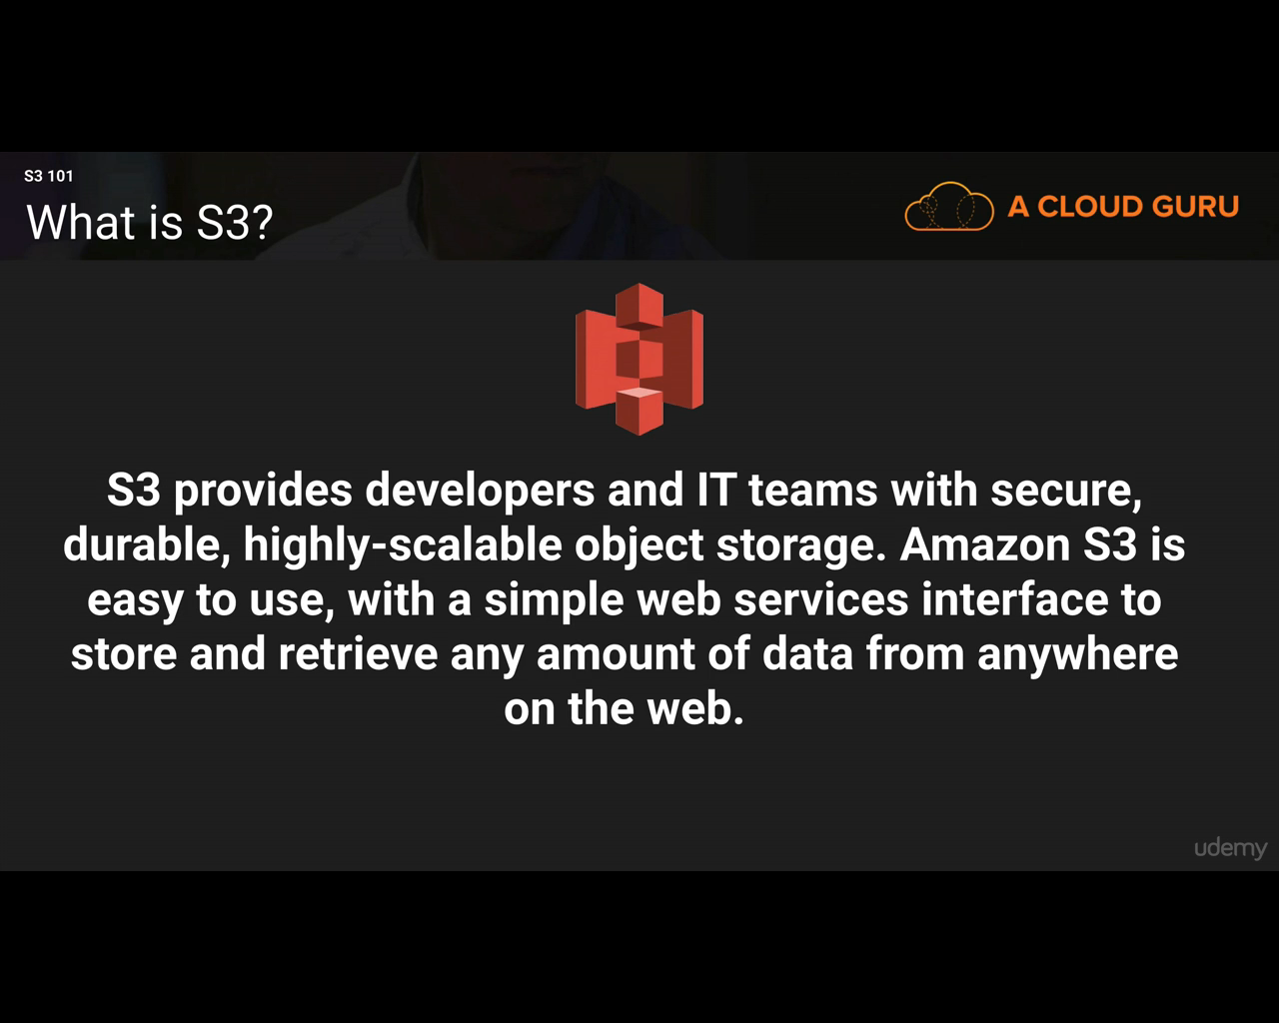

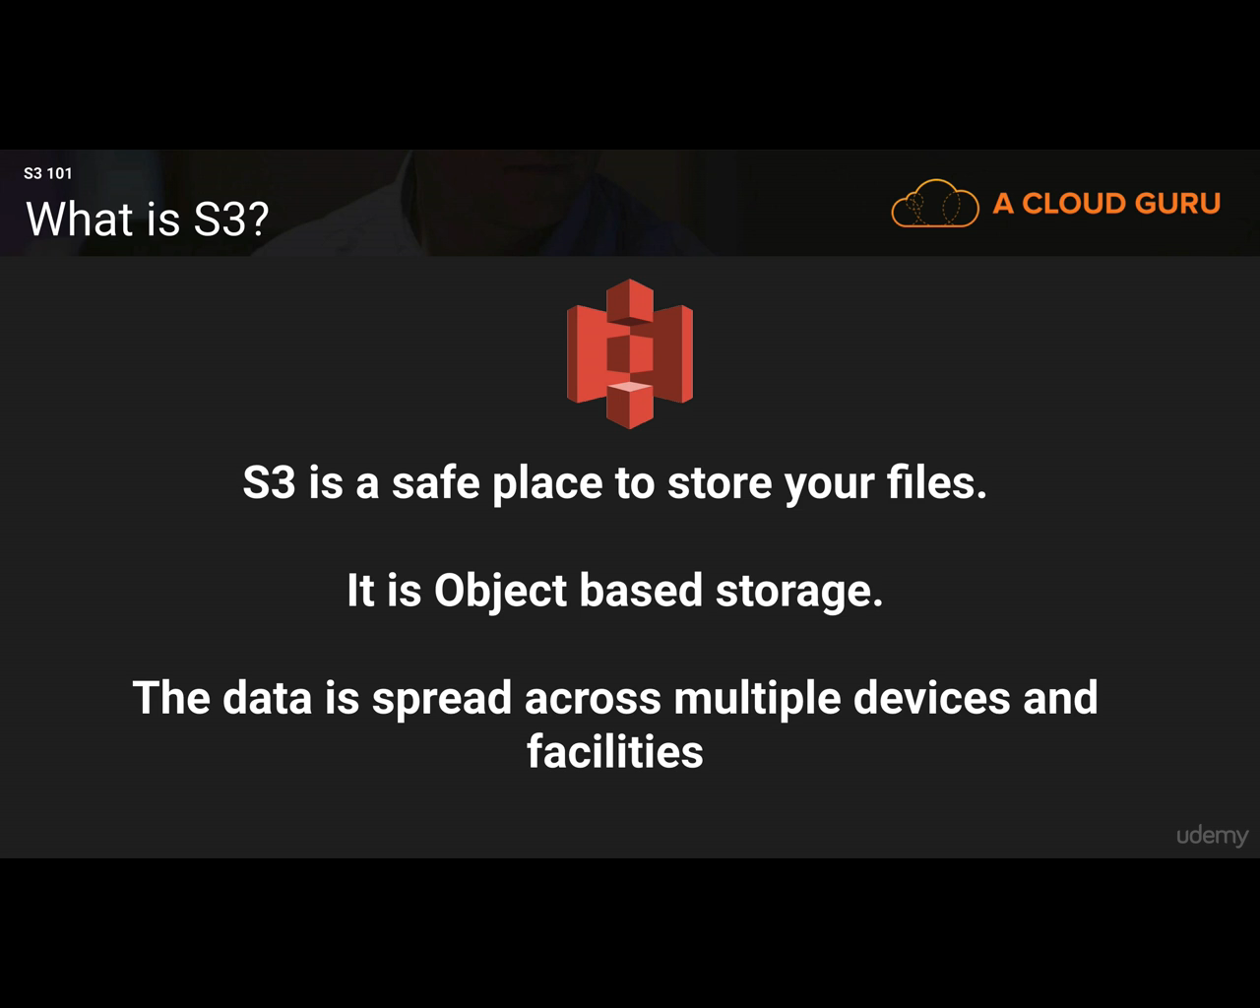

Storage can be Block (OS or DB) based or Object (photos, videos, pdf, word, flat files) based. S3 is object based storage.

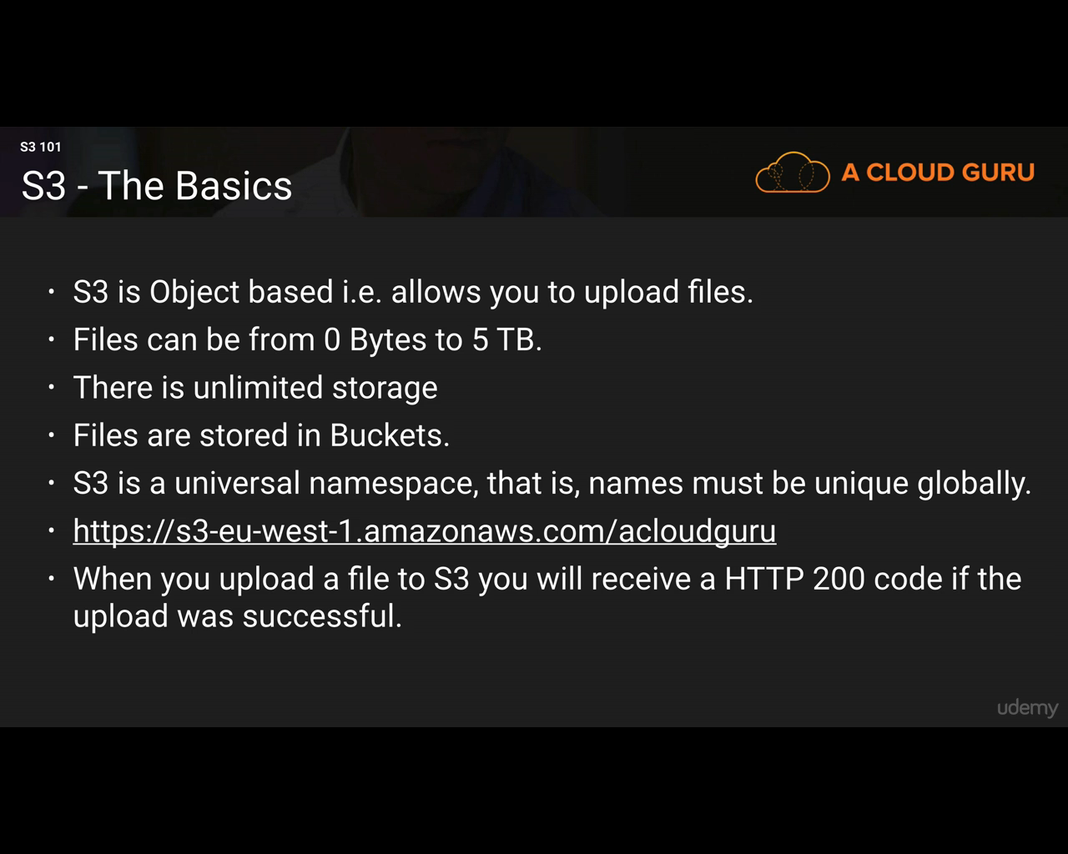

Remember the DNS pattern:

[https: //s3-region.amazonaws.com/bucketname](http://s3-region.amazonaws.com/bucketname)

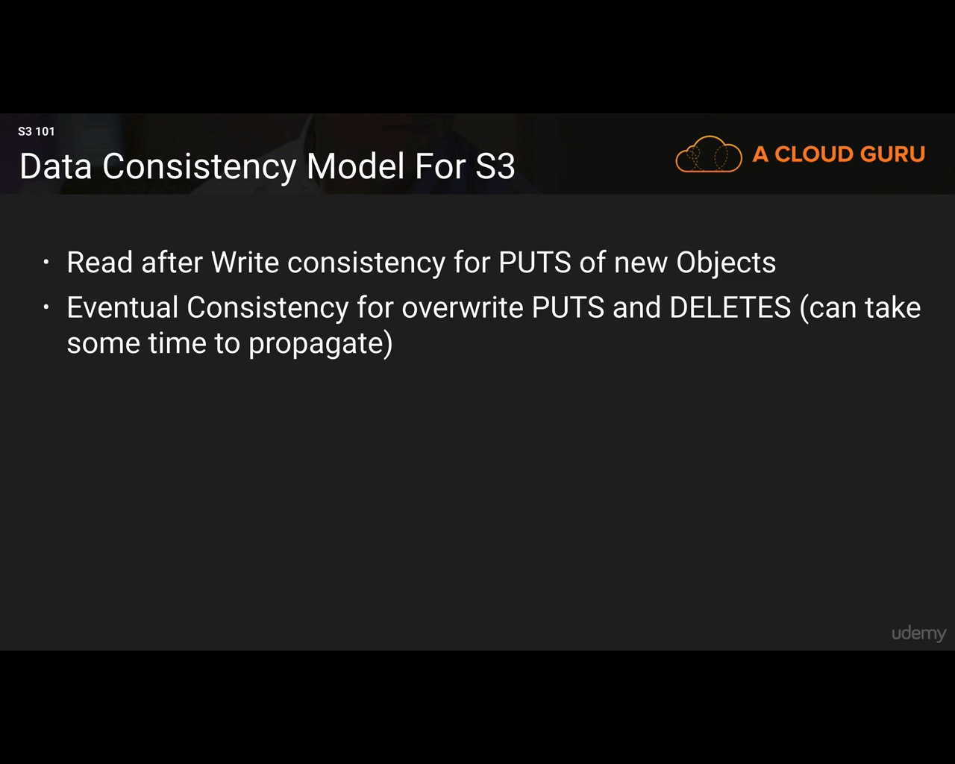

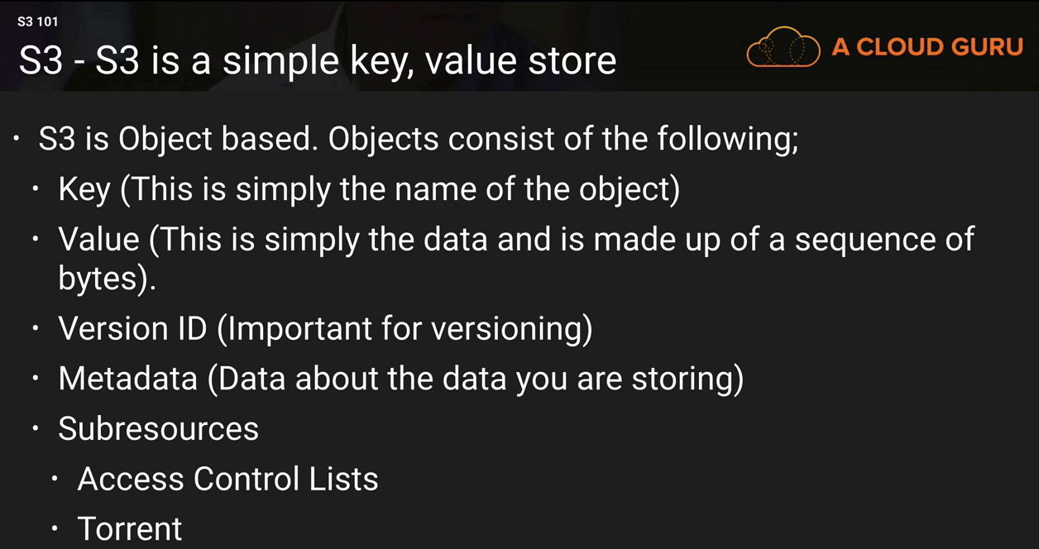

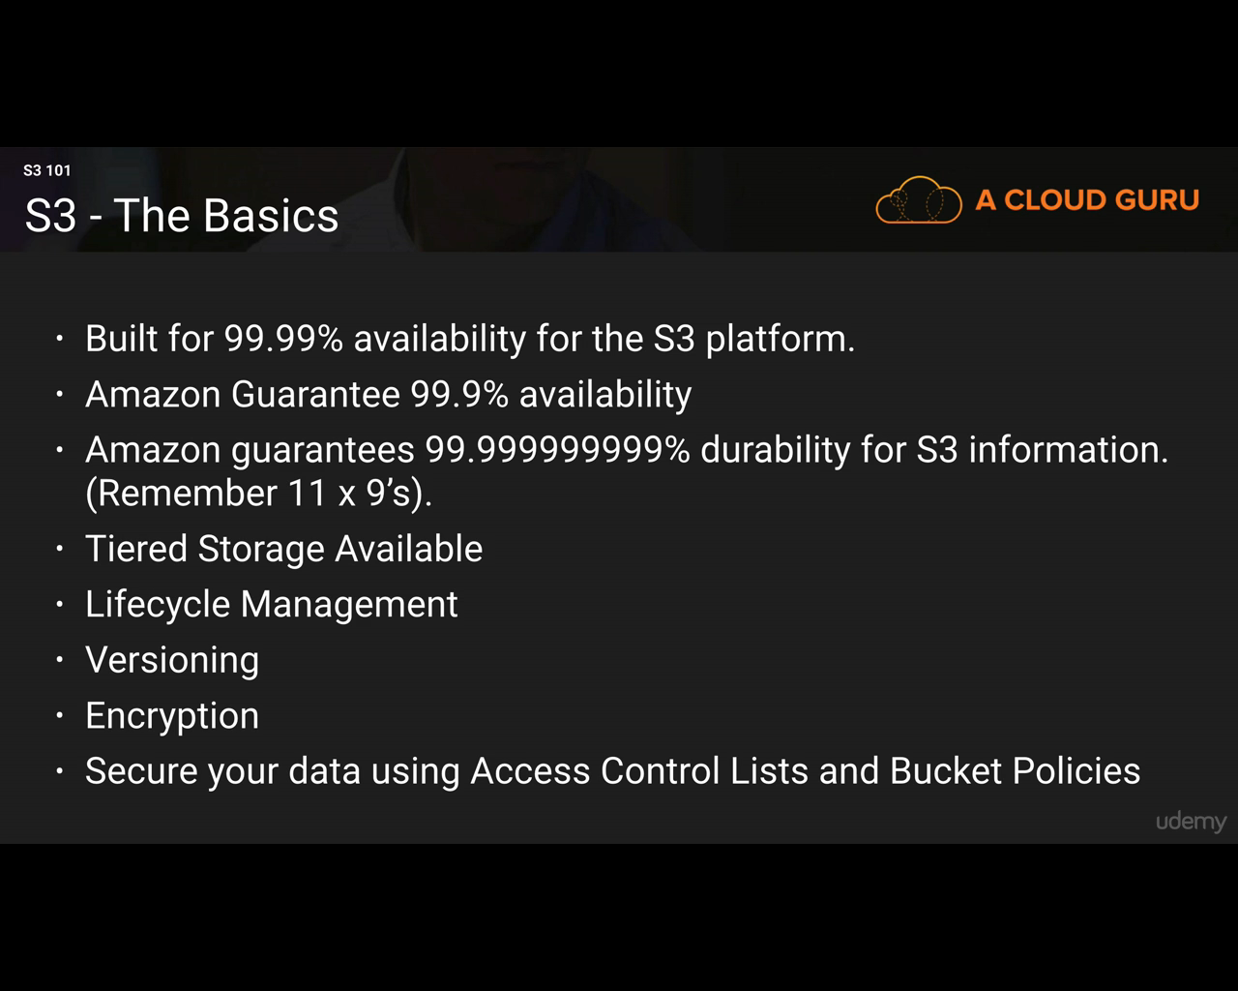

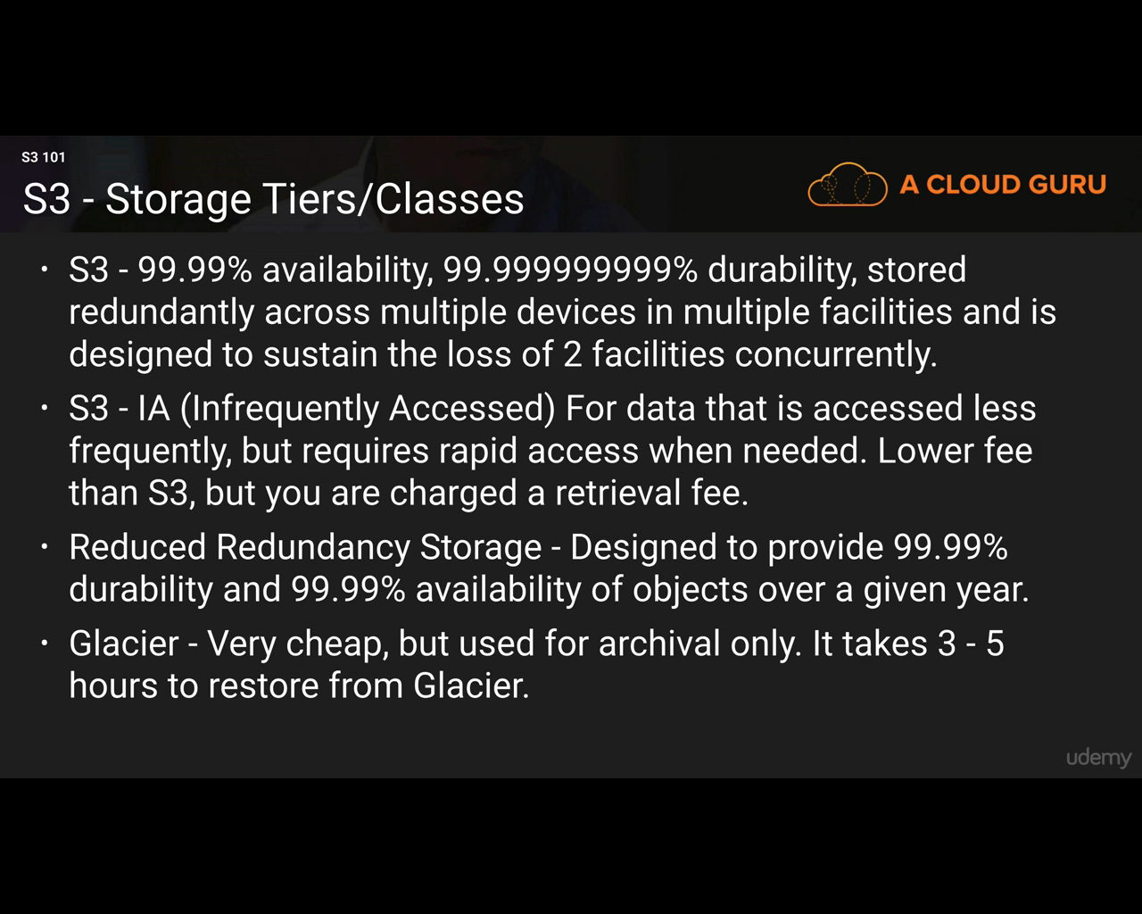

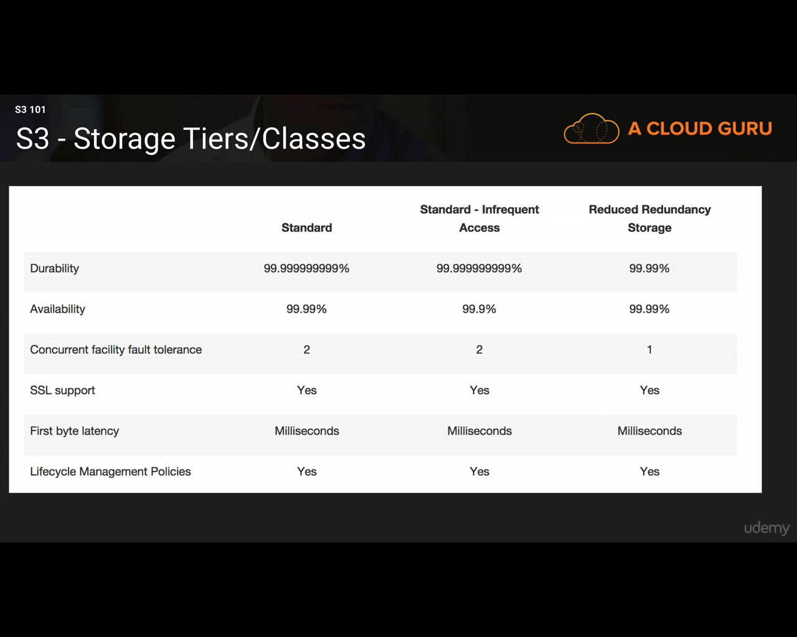

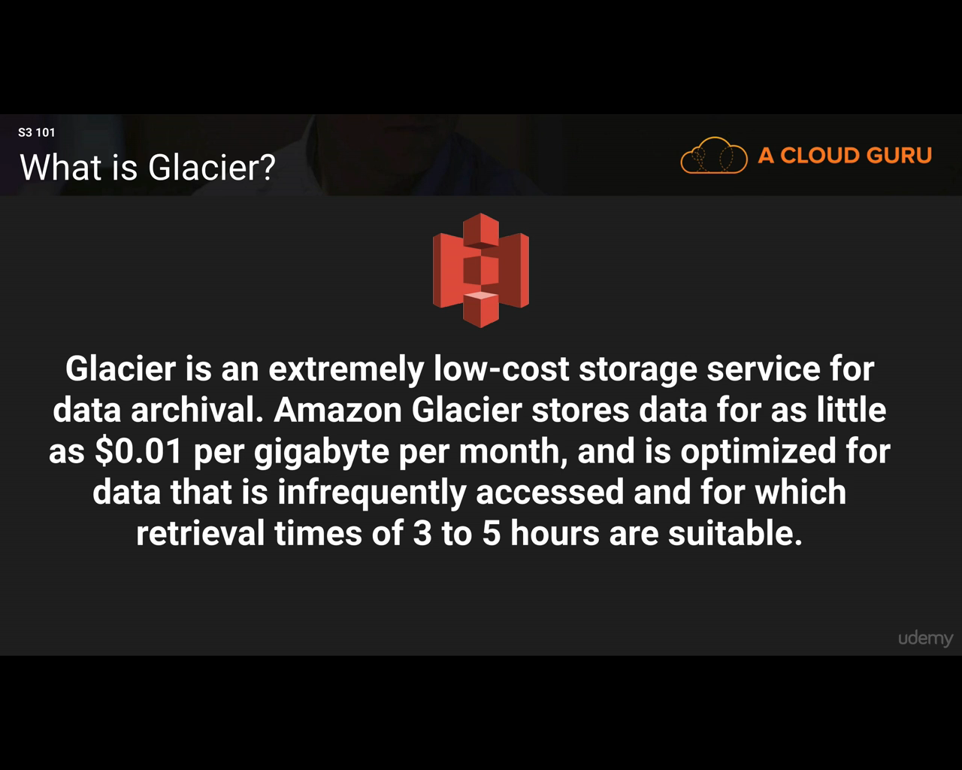

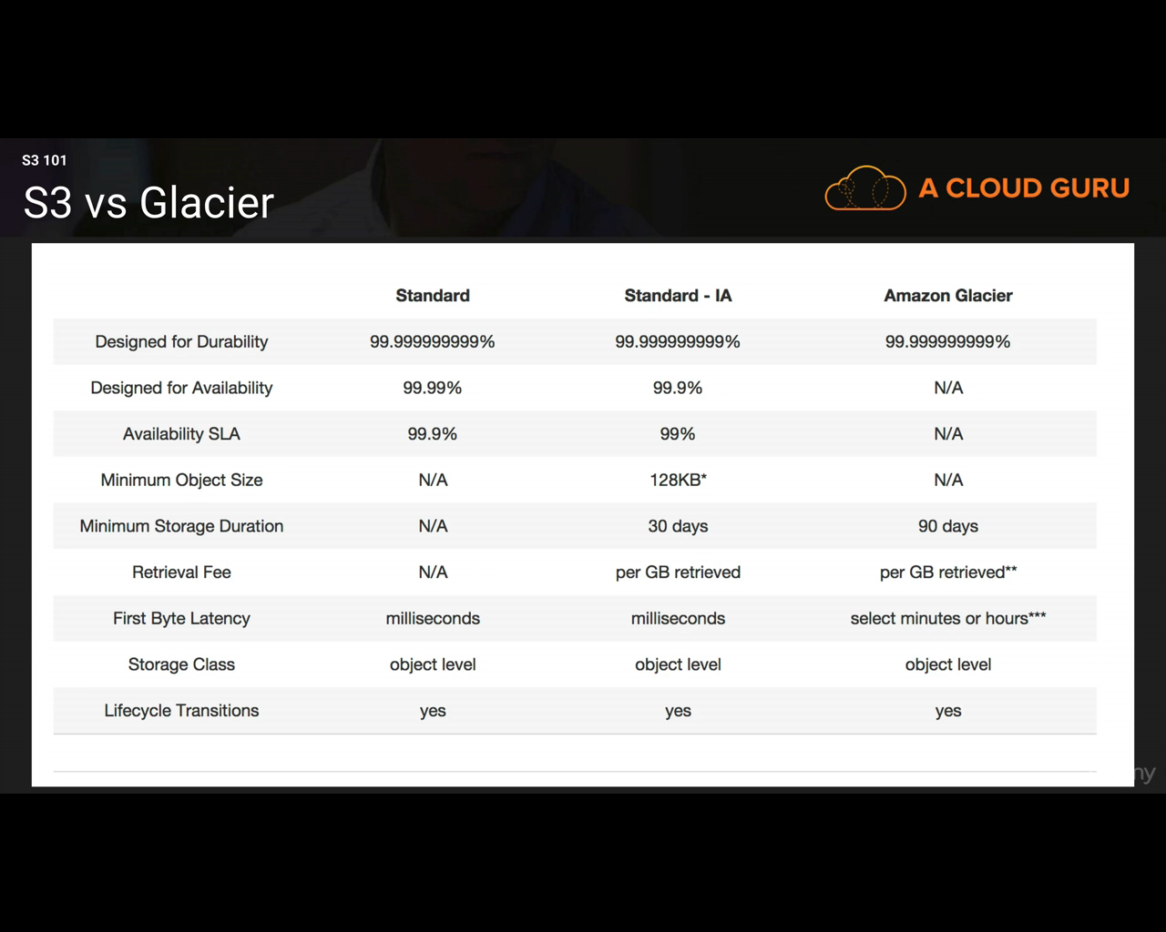

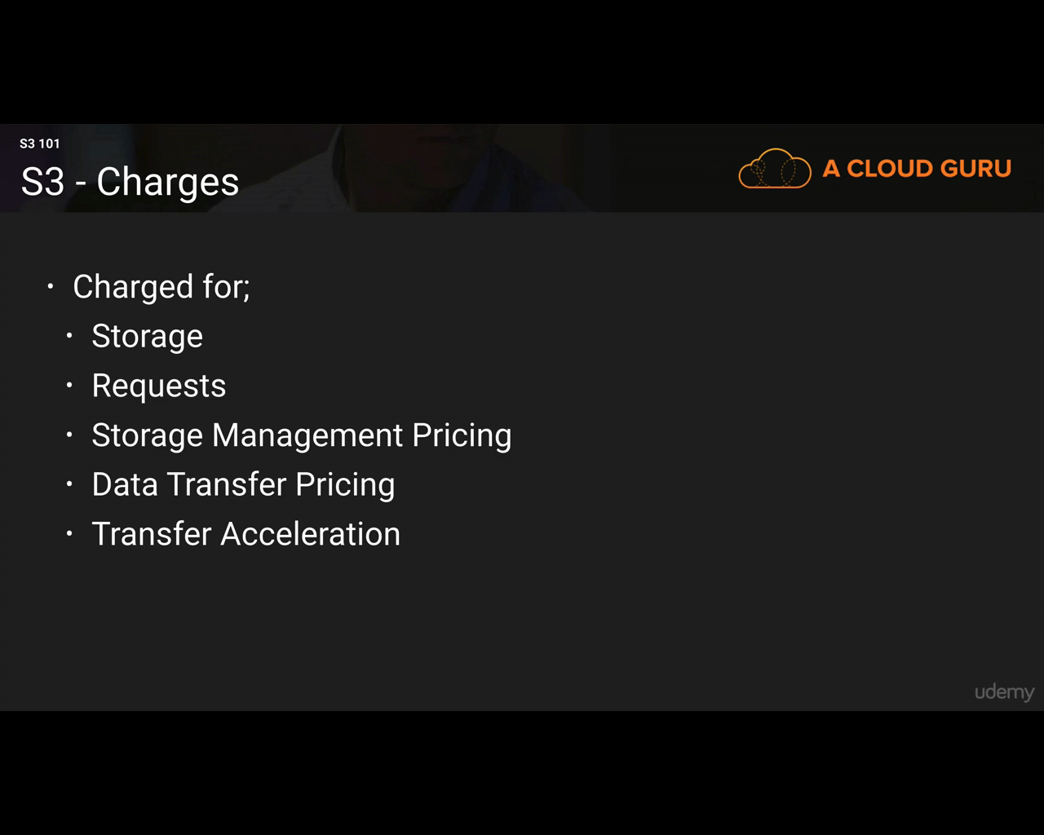

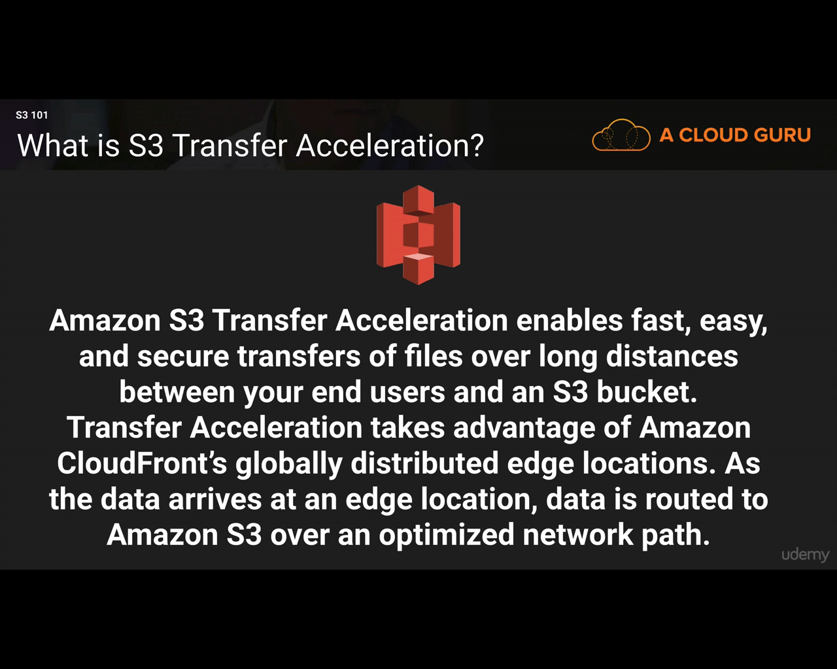

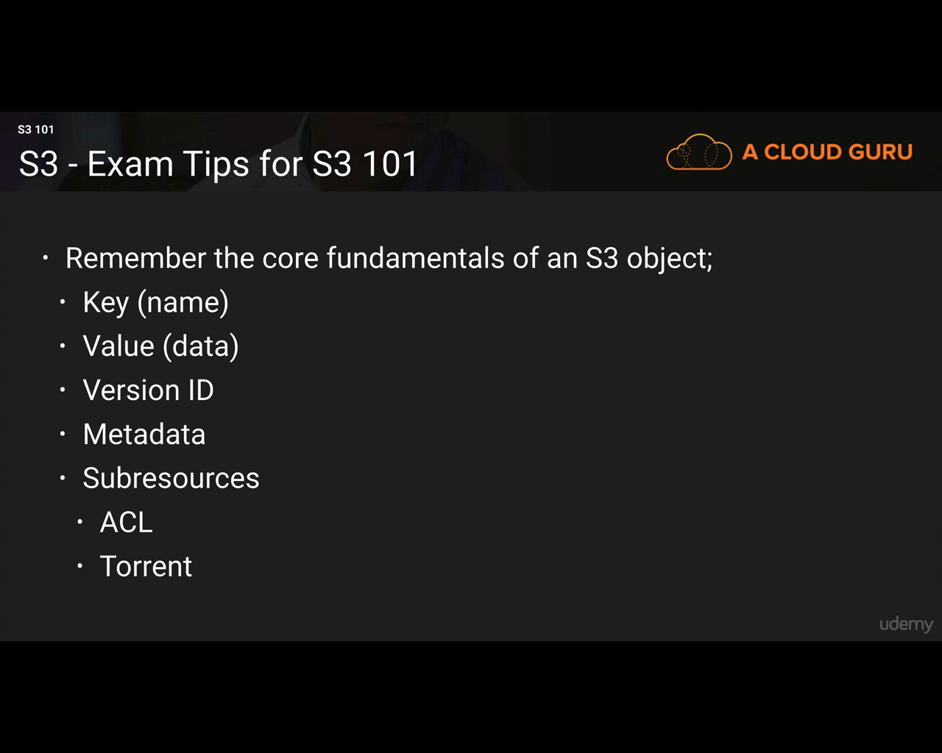

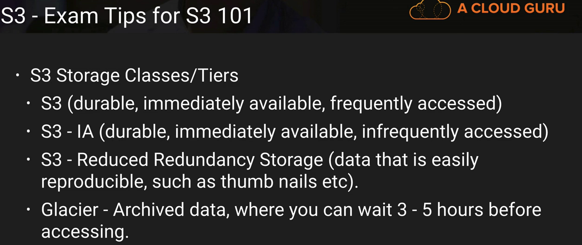

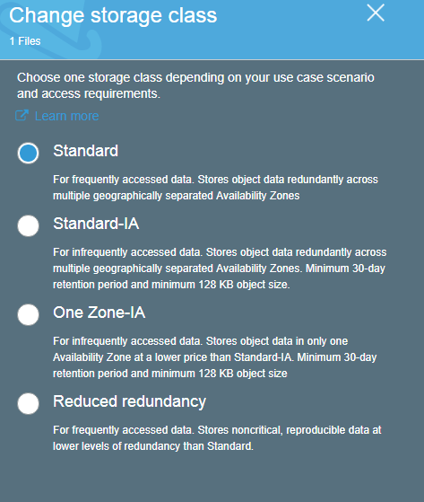

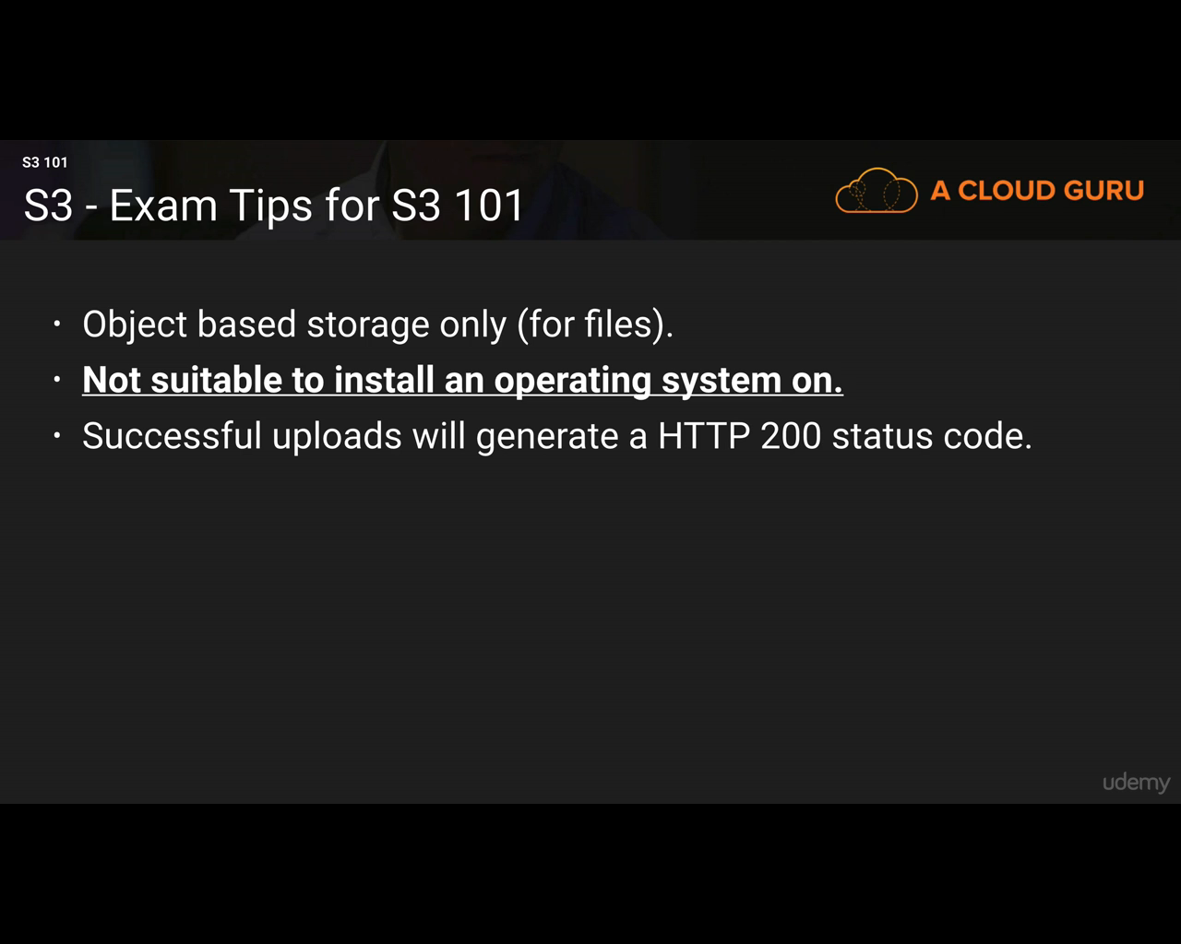

1) S3 buckets

a) It is global

b) S3 bucket name should be unique (It is because,it is using DNS space)

c) By default, our buckets are private and all the objects inside the buckets are also private.

d) There are two ways to control access to Buckets; they are ACL (Access Control List) and Bucket Policies.

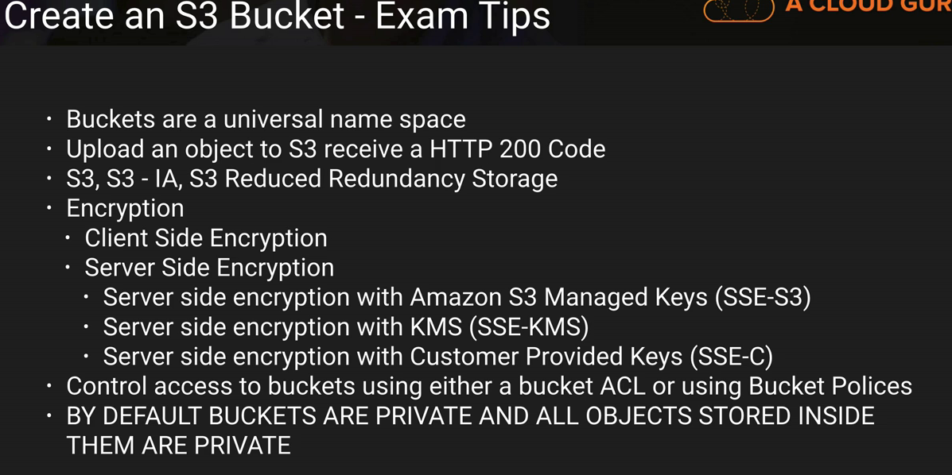

**Versioning a bucket**

Versioning is in Management Tab. Versioning can be enabled or suspended. Not disabled.

Once we enable versioning, we cannot disable that version instead we can only suspend that version.

Every time the file changes, there will be a different copy of that file(original file and the changed file) sitting inside the S3.

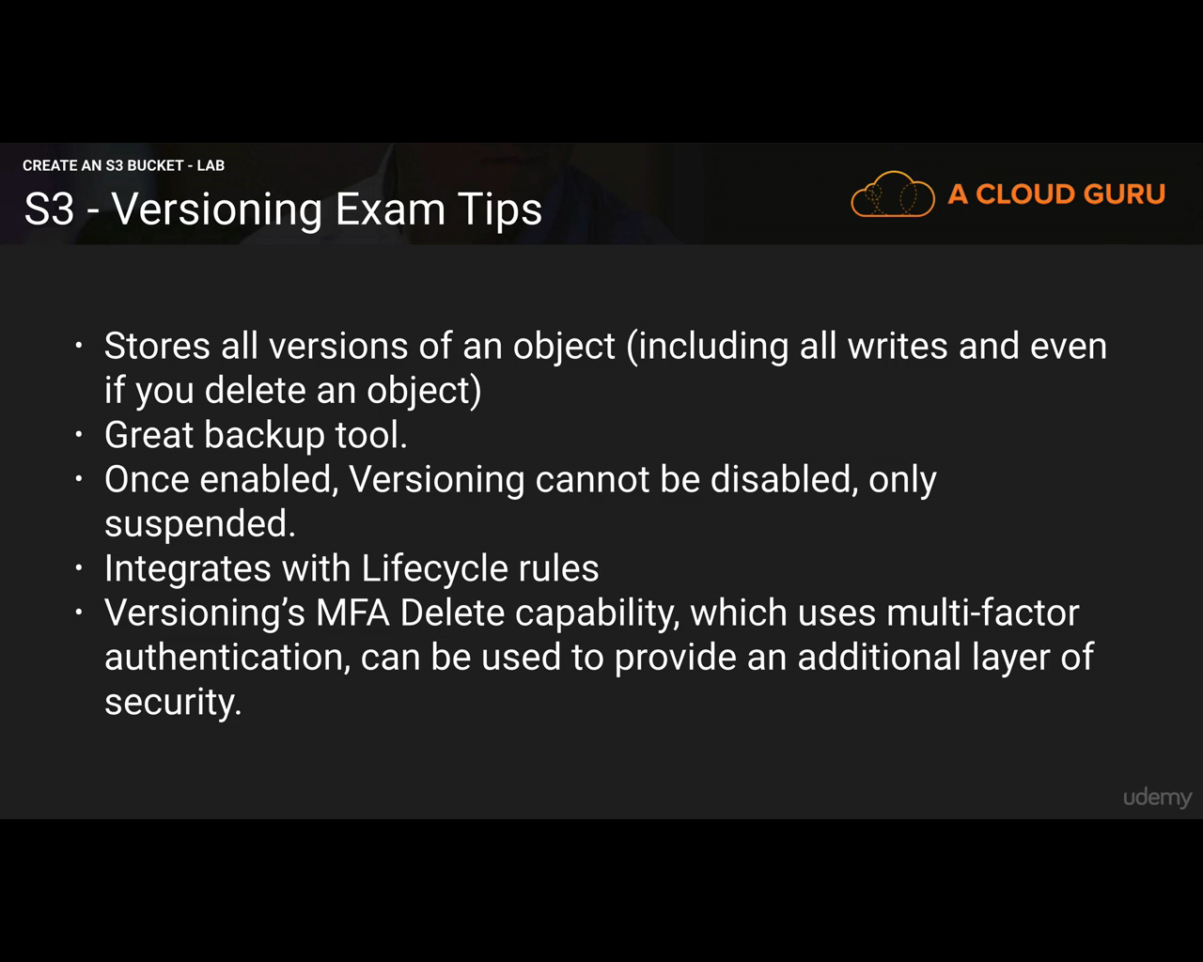

**Cross Region Replication**

To replicate content from one region to another. It doesn’t replicate the current content but the future updation or addition.

Install AWS command line tools. Go to cmd: aws configure.

aws s3 cp --recursive s3://sourcebucketname s3://destinationbucketname

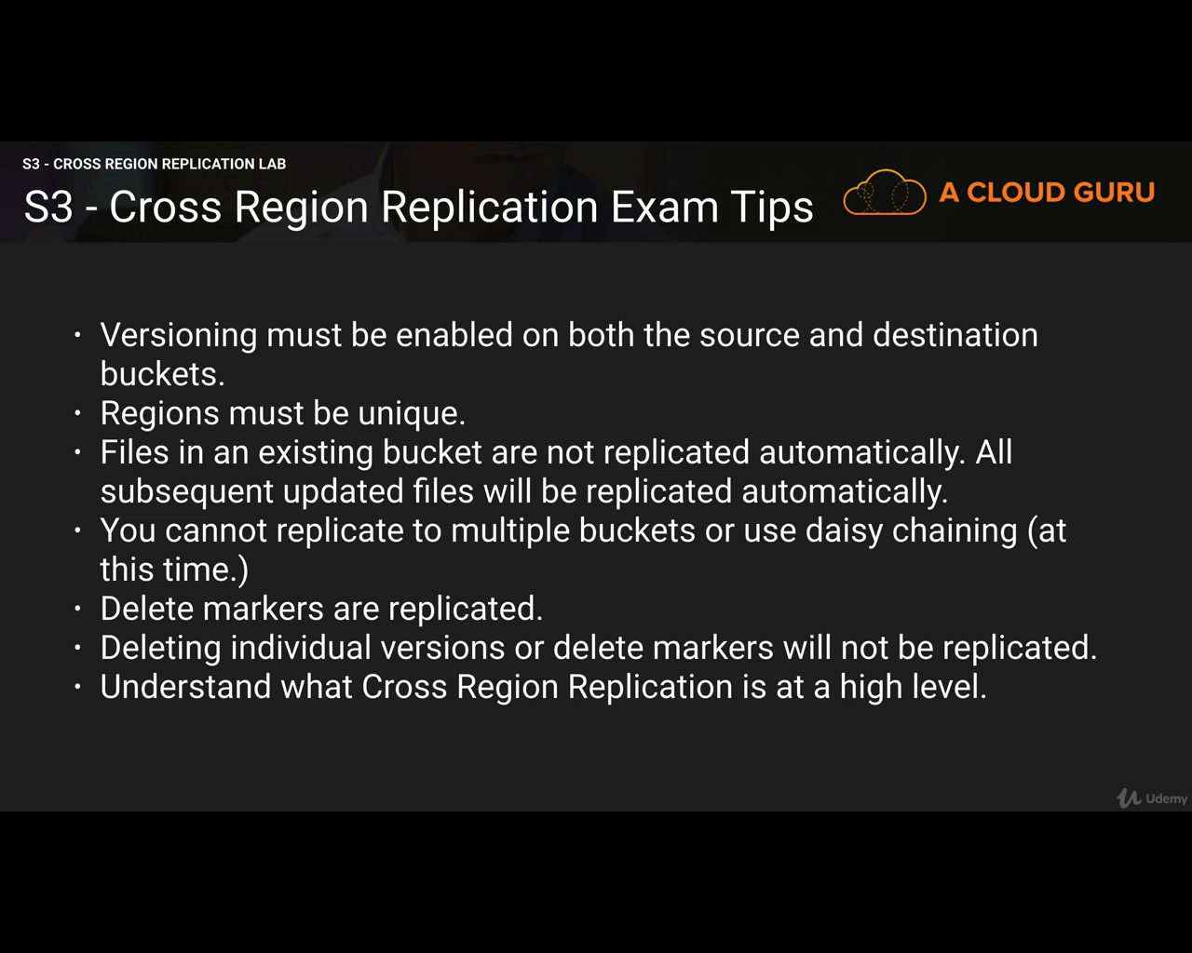

**Lifecycle management and Glaciar**

Glaciar is not supported in Singapore and South America.

Glaciar: Another service, it integrates tightly with S3.

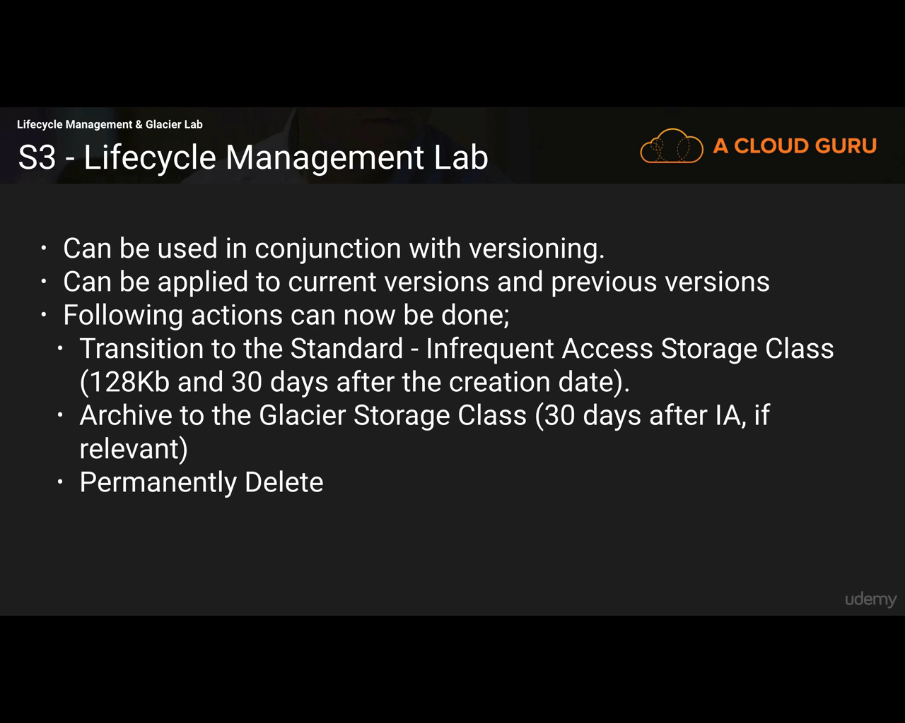

**CloudFront**

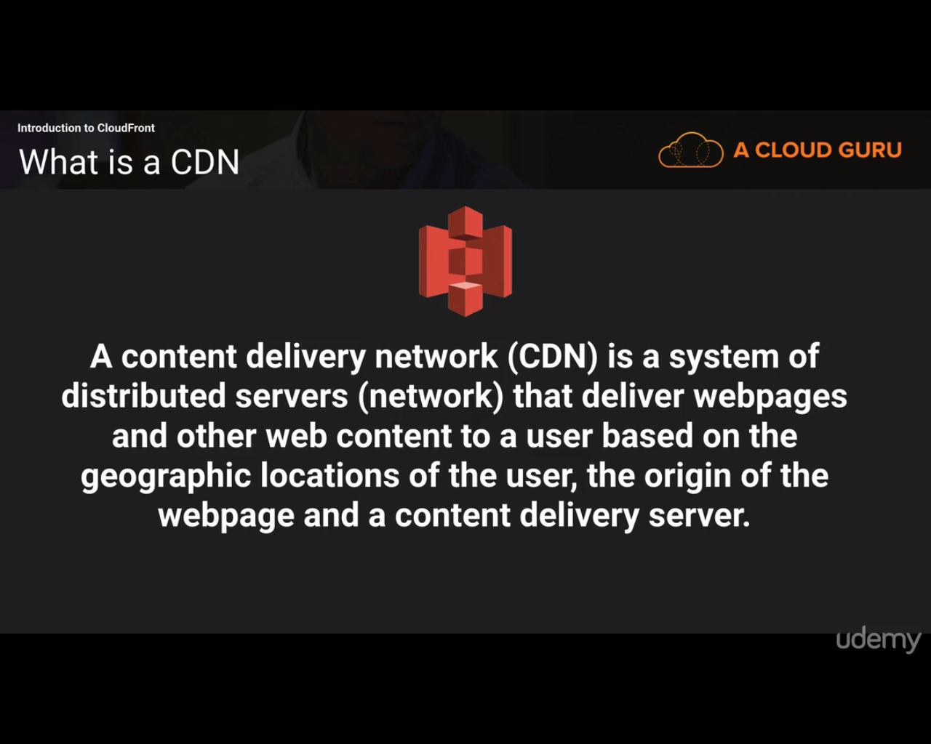

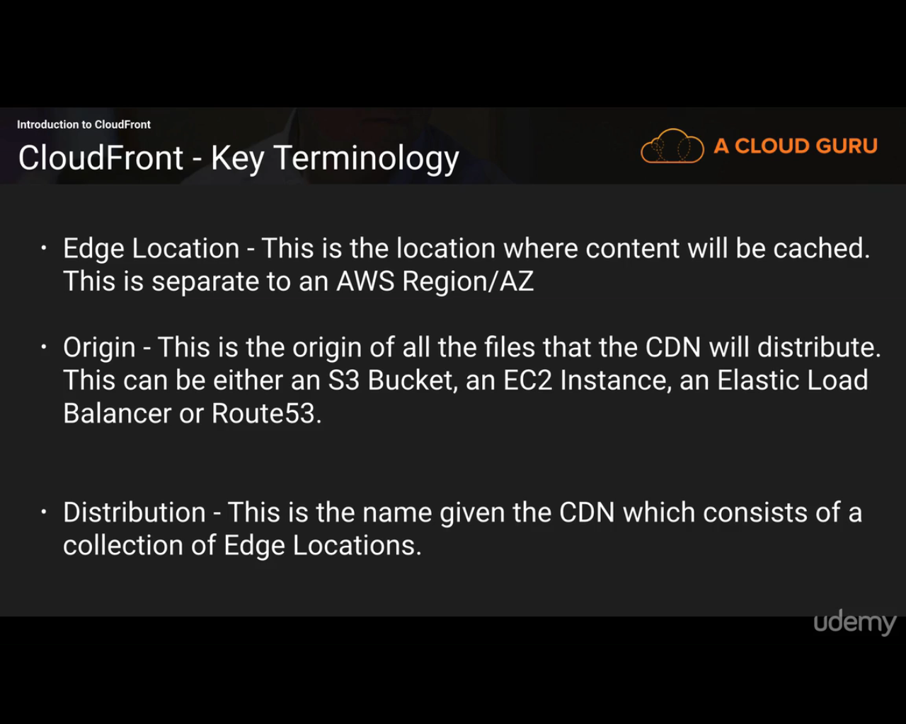

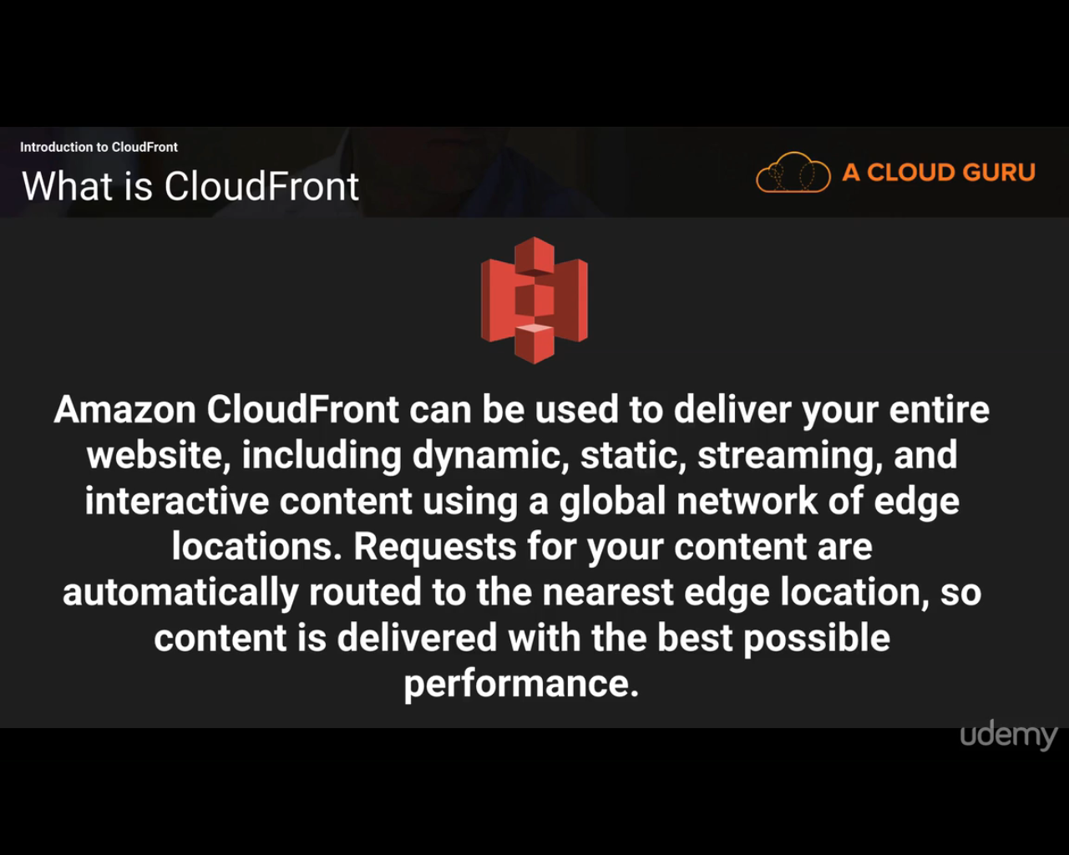

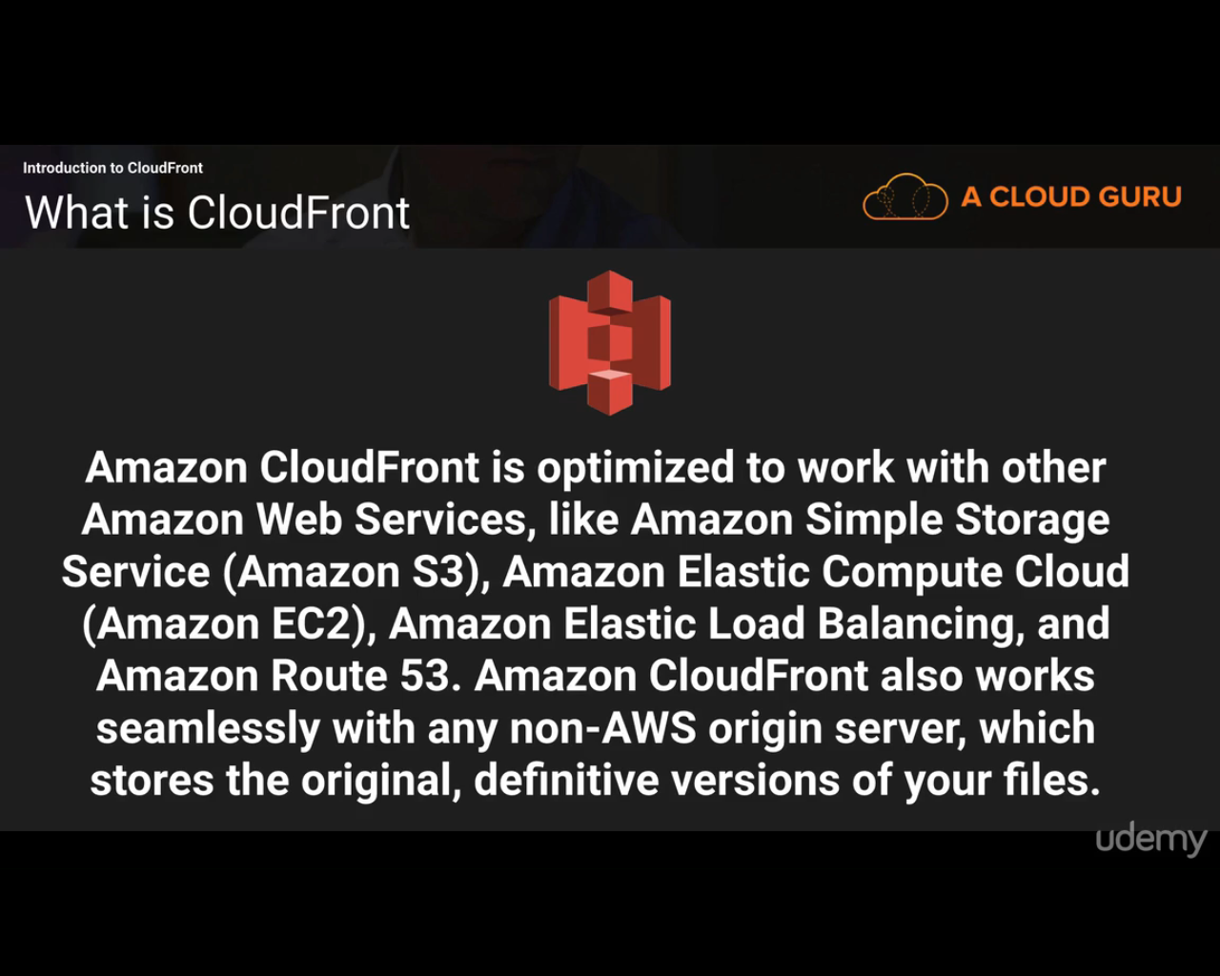

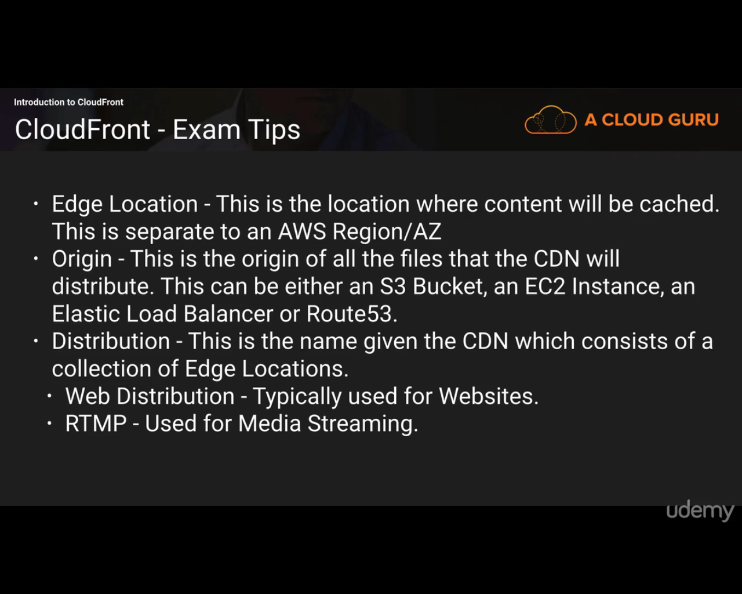

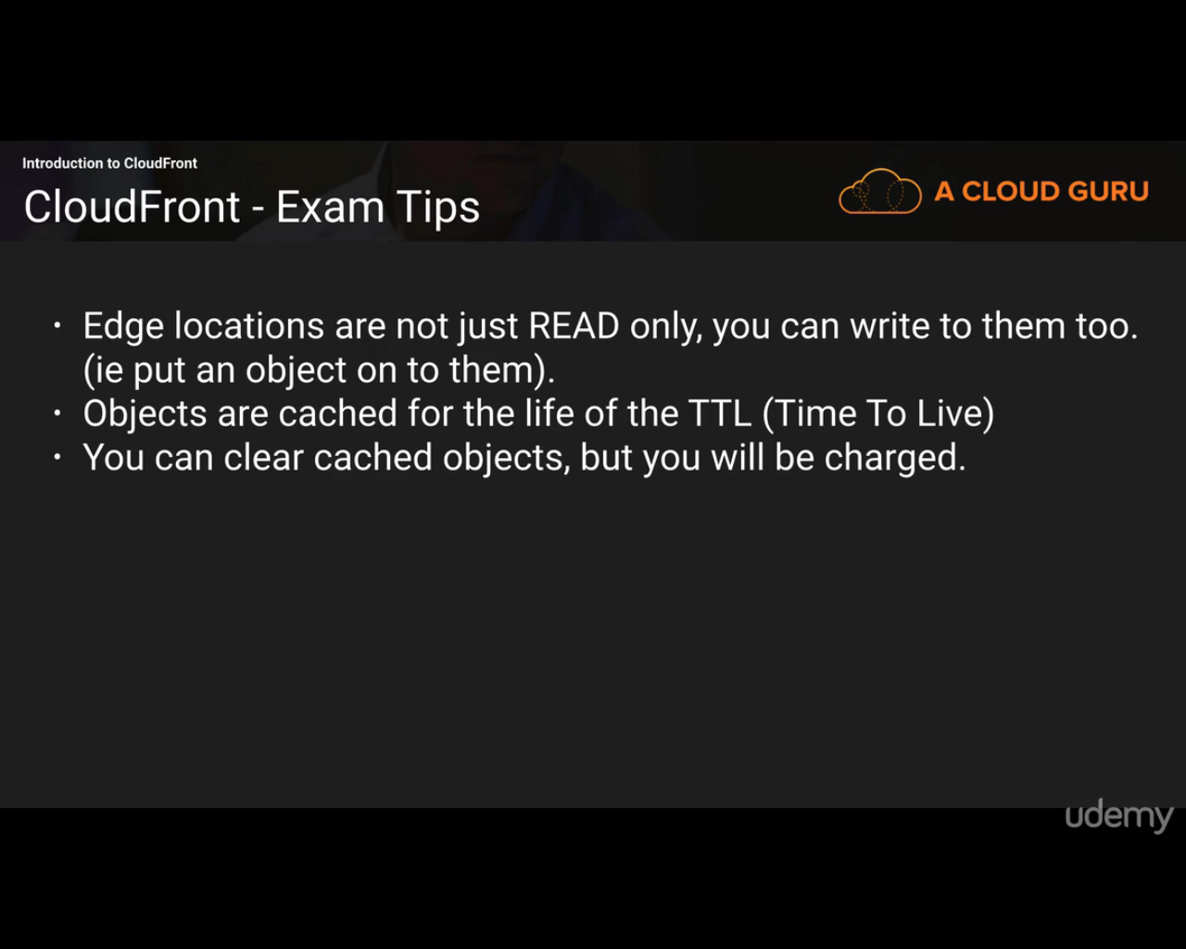

**--------------------------------------------------------------------------------------------------------------------------------------------------------**

**Security**

Bucket policies- Bucket level.

Access Control Lists- object/ file level.

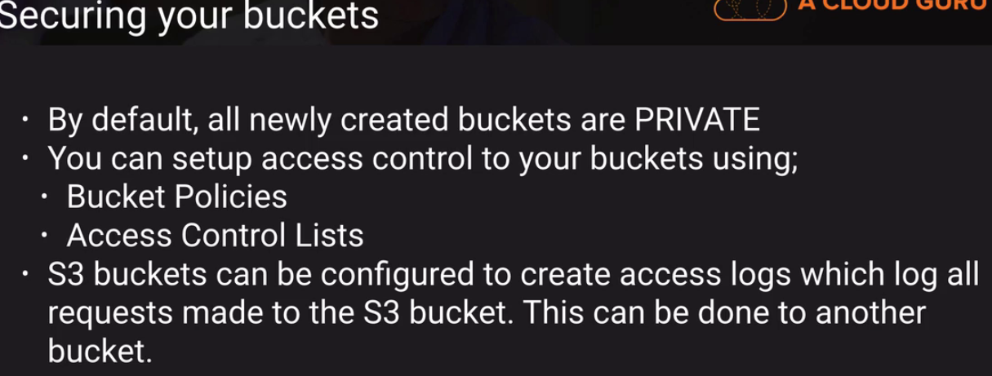

**Encryption**

4 Types:

1. In transit- to and from bucket.. on premise to bucket and vice versa. TLS is replacement of SSL
2. At rest- (when data is in AWS)
3. Server Side Encryption
4. S3 managed Keys- (most common) SSE-S3
5. AWS Key Management Service, Managed keys- SSE-KMS (more costly than above)
6. Server Side Encryption with Customer Provided Keys – SSE-C (You manage keys and AWS manages encryption.
7. Client Side Encryption

----------------------------------------------------------------------------------------------------------------------------------------------

**Storage Gateway**

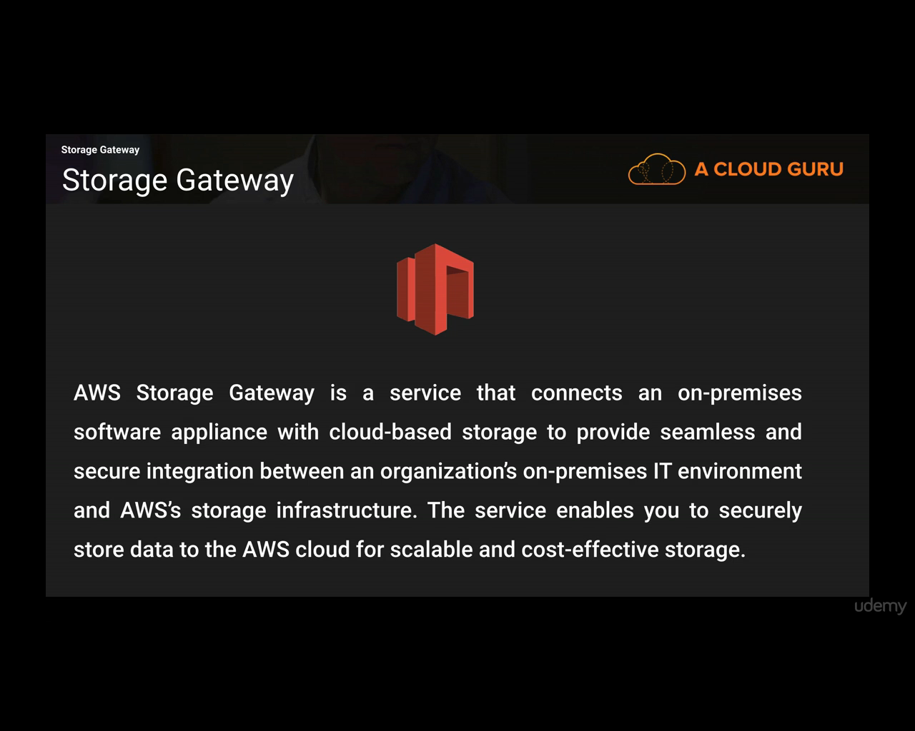

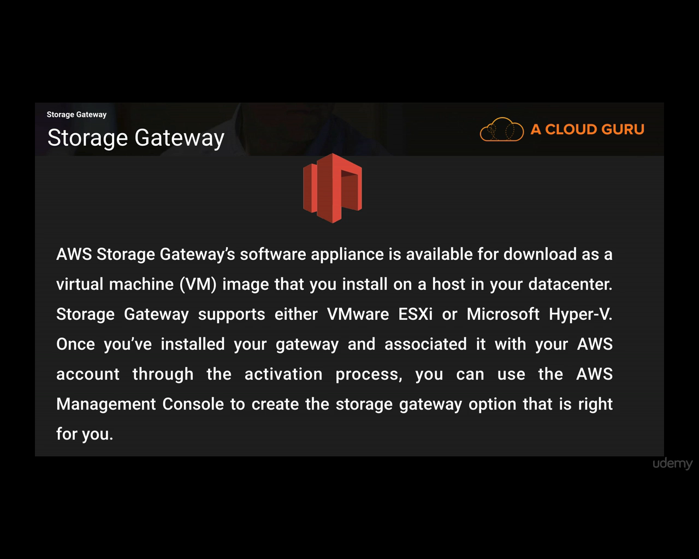

**Four Types**:

1. File Gateway: Uses NFS. Used to store flat files in S3.
2. Volumes Gateway: Uses iSCSI. Block Storage. And object storage too.
3. Stored Volumes: All data on premises
4. Cached Volumes: only recently used data is on premises. And other data is backed off to aws.
5. Tape Gateway: Uses VTL(Virtual Tape Library). Back up archive. Uses virtual tapes and send them to s3. Then you can use Lifecycle policies to send them off to glacier.

1. **File Gateway**

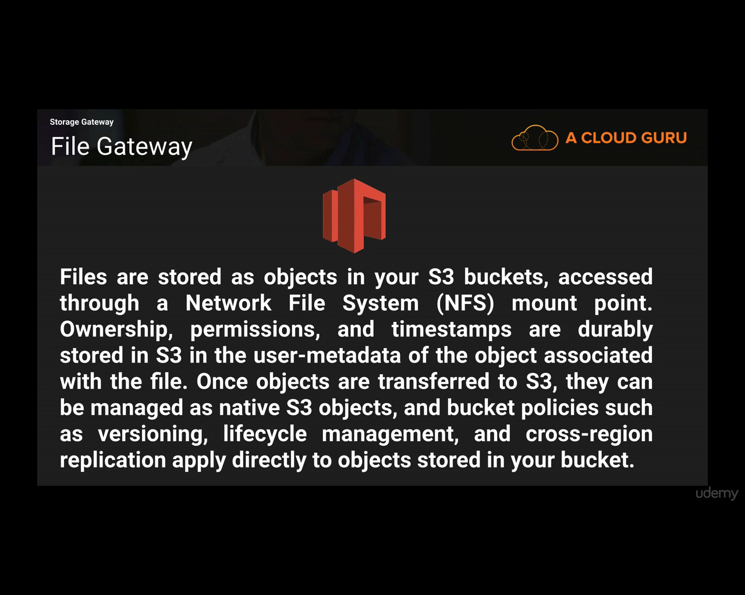

**Infrastructure of file gateway:**

Storage gateway is VM running on your on premise host machine.

Direct Connect: Dedicated communication line between your datacenter and AWS

Internet: Most common way

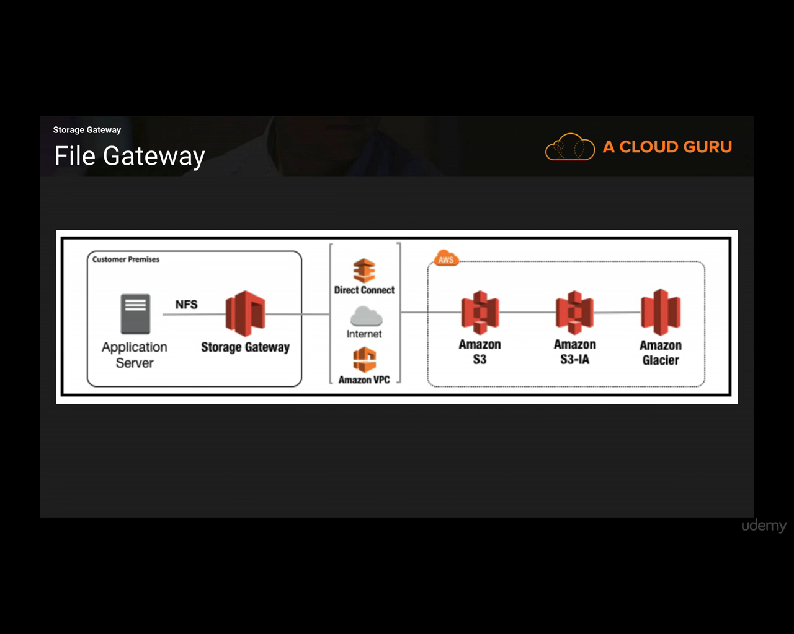

2. **Volume Gateway**

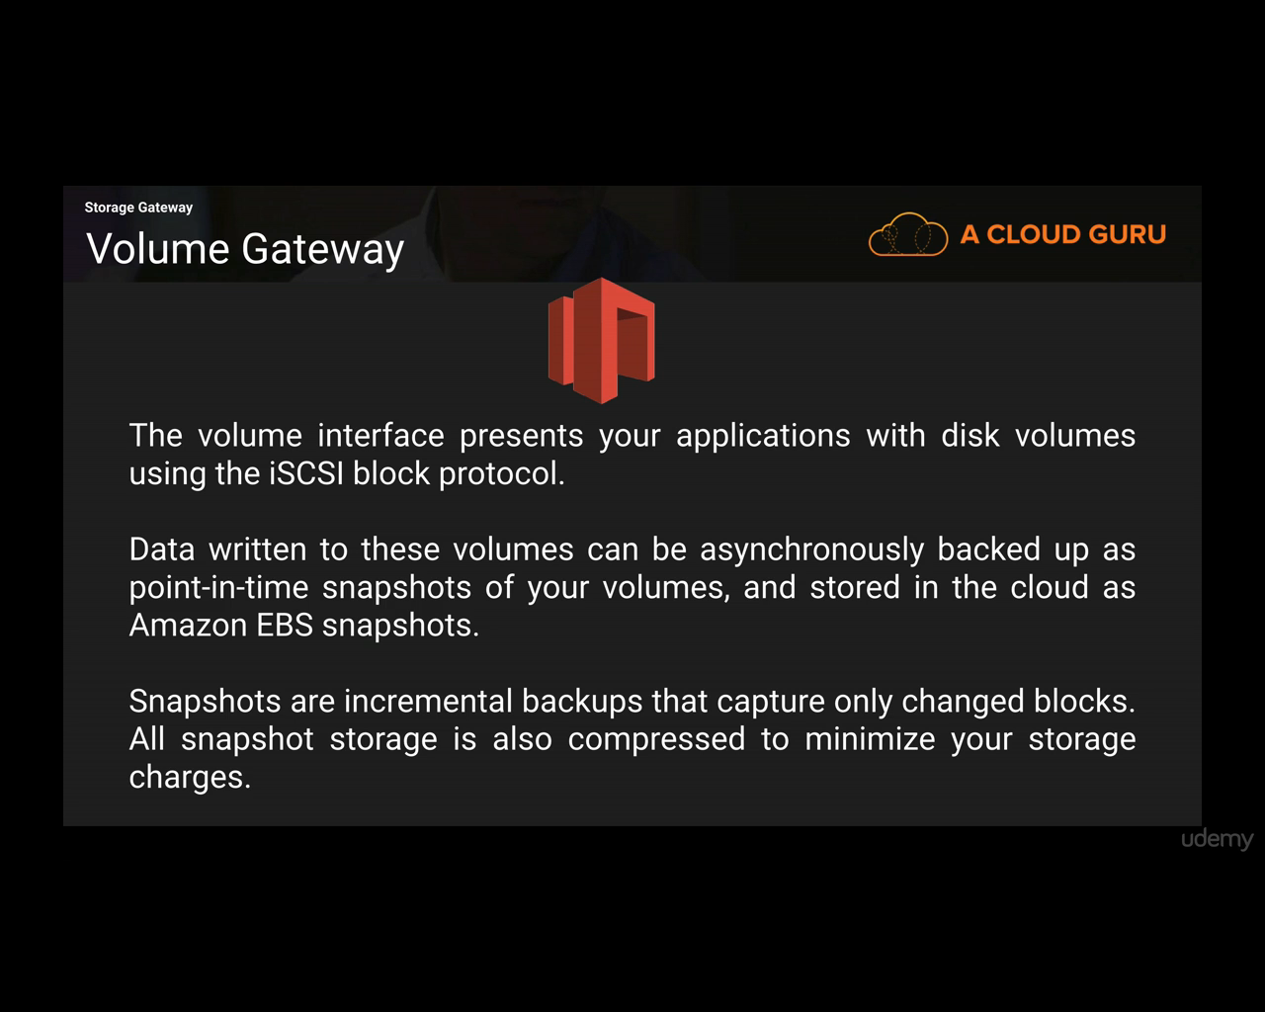

EBS: Virtual hard disk attached to EC2 instances

1. **Stored Volumes**

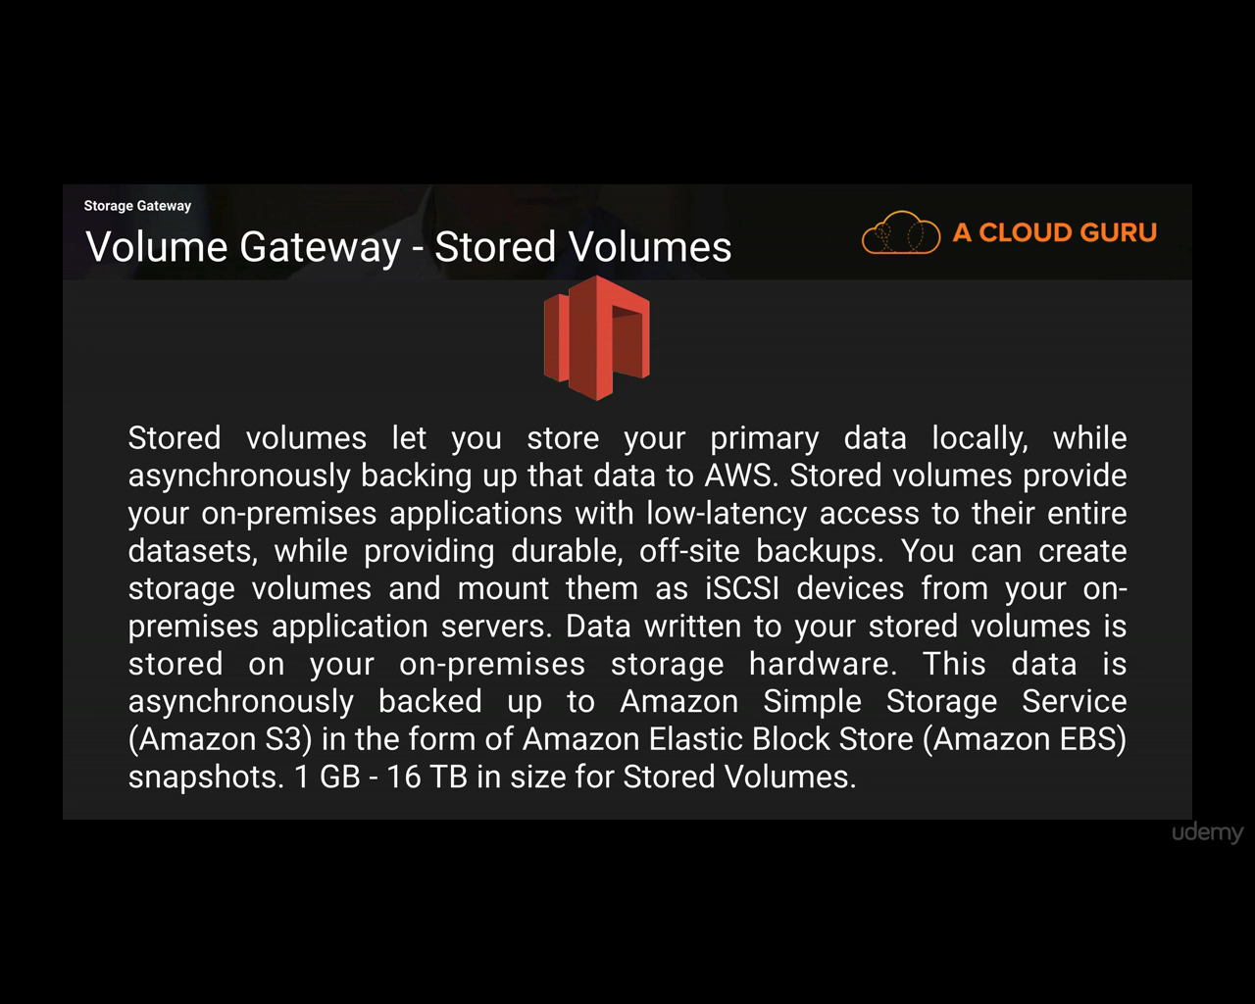

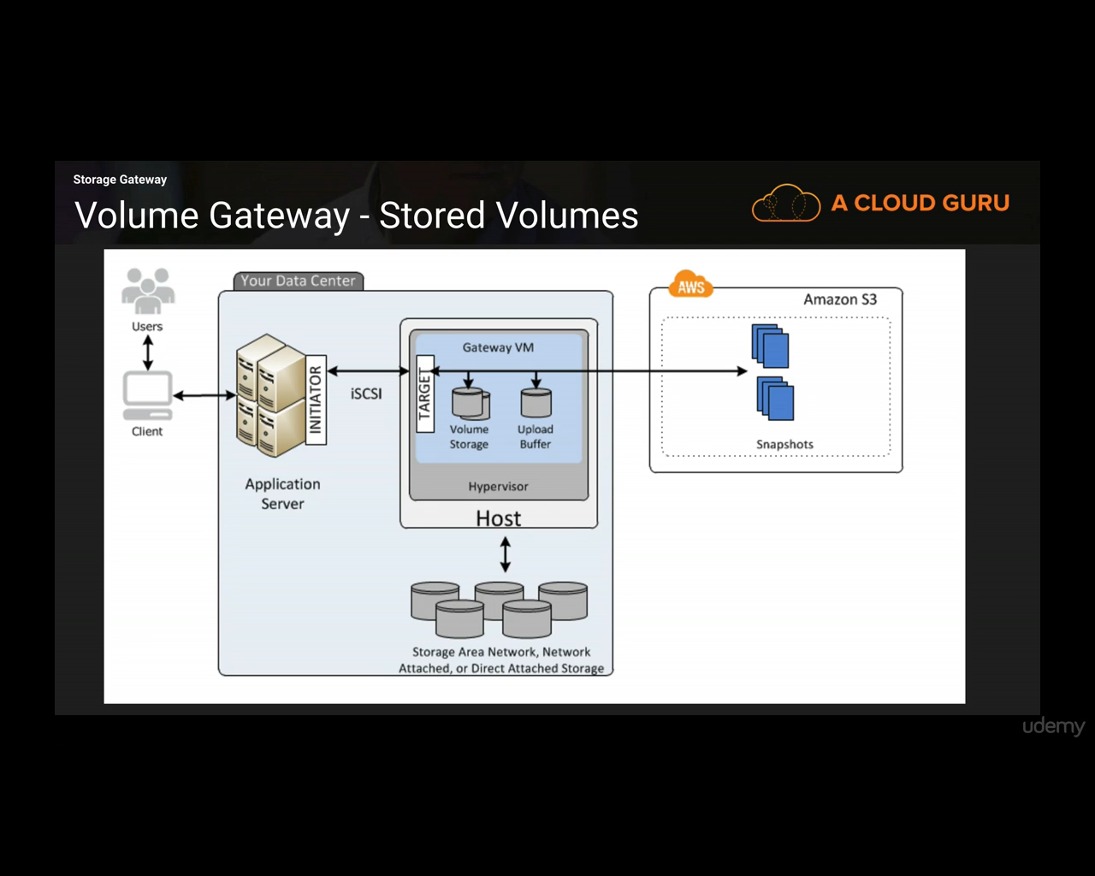

1. **Cached Volumes**

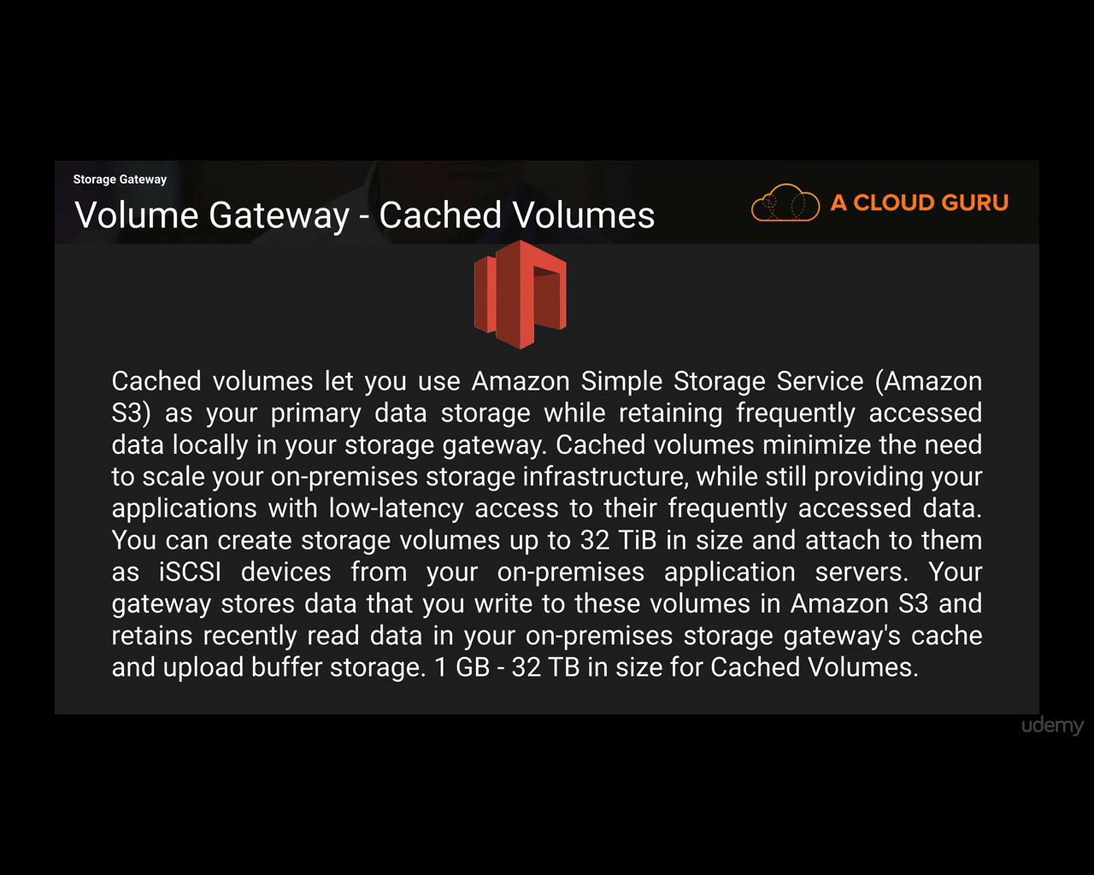

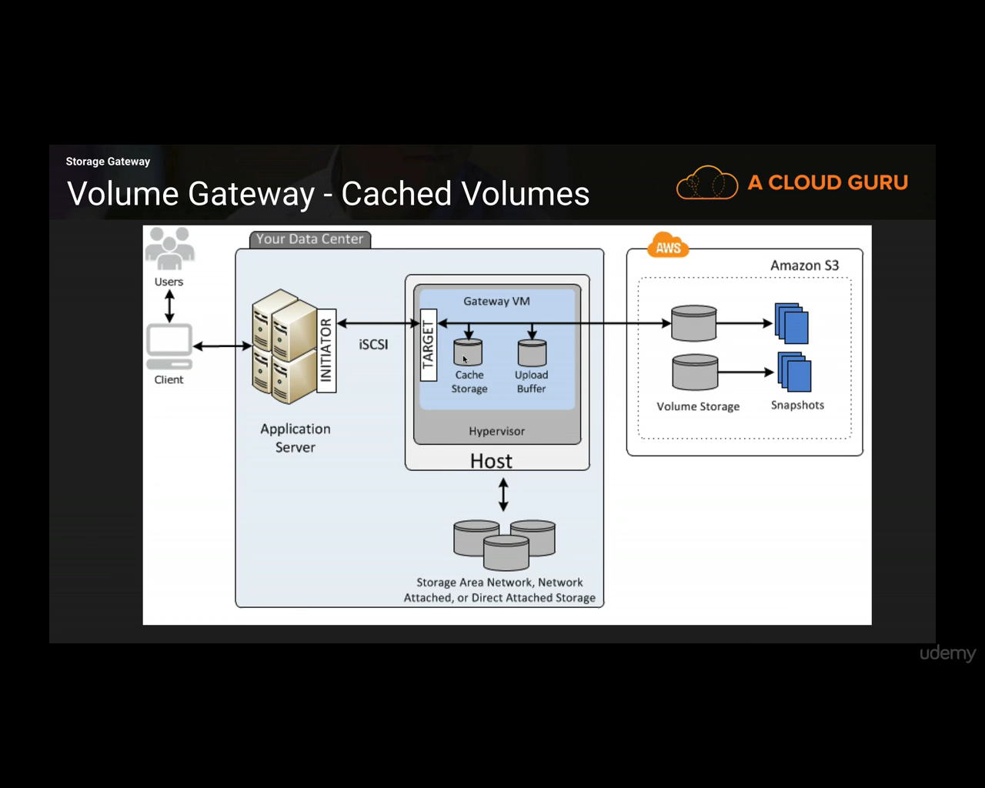

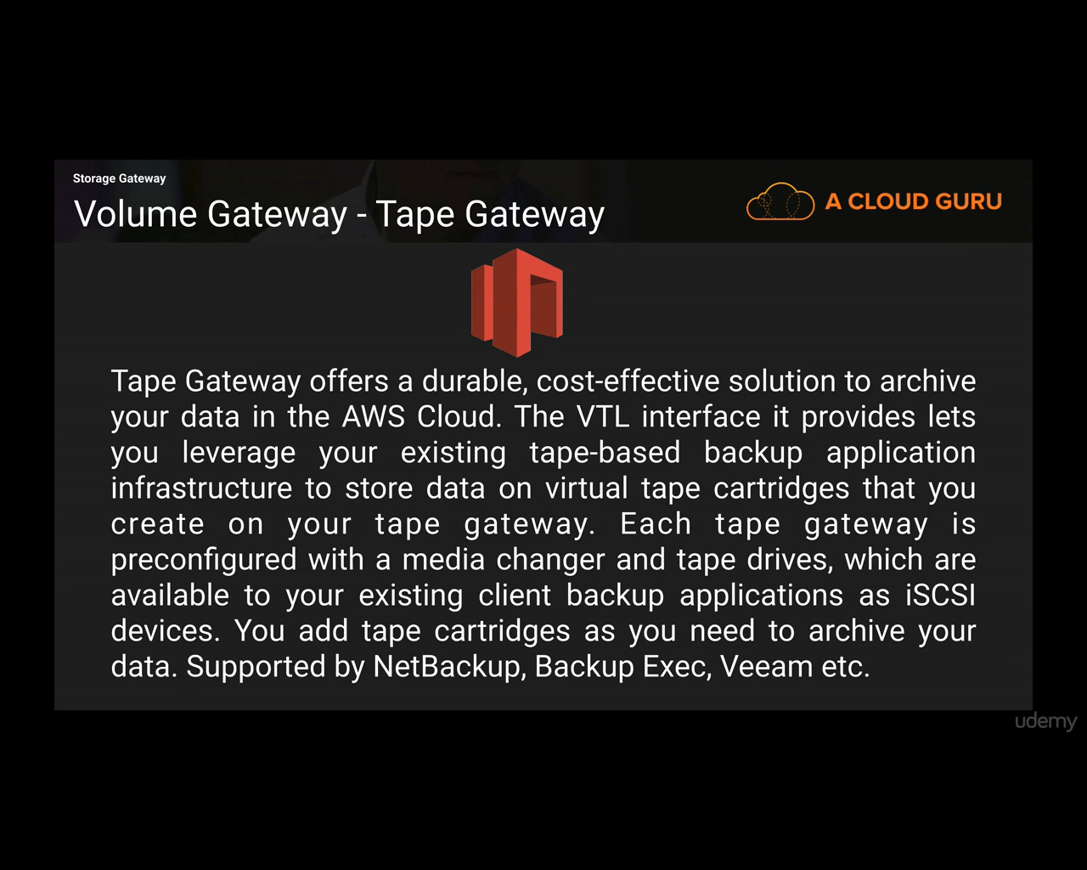

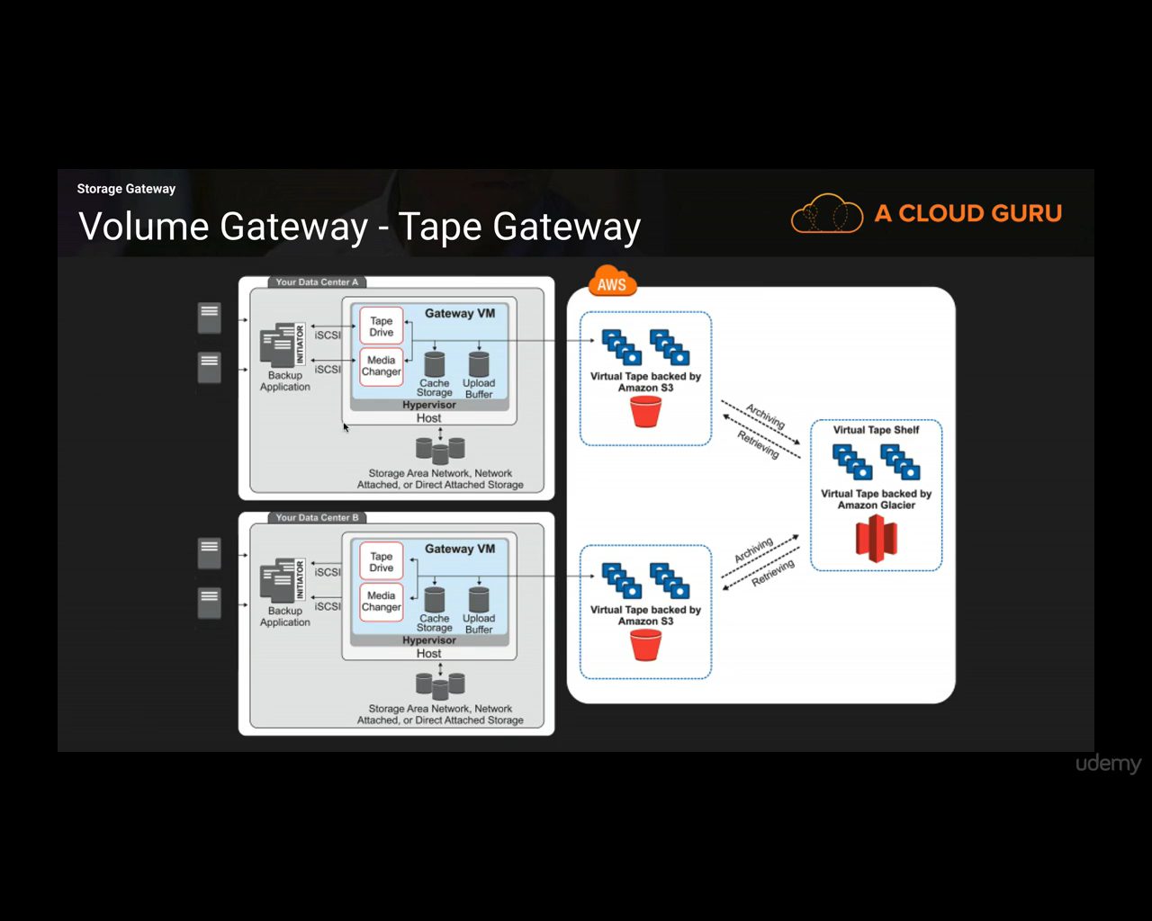

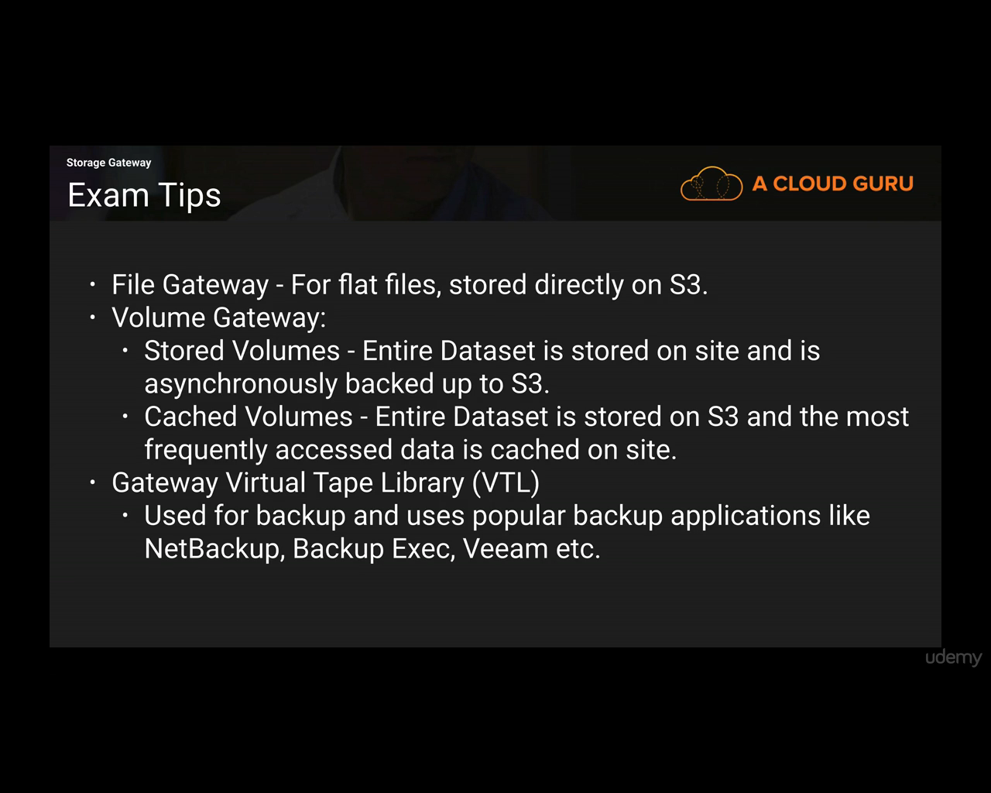

File Gateway- Cheaper

Stored Volumes – if low latency is needed

Cached Volumes – if you don’t want to put whole data on client side

Tape Gateway – Low price.

**Snowball**

Before Snowball, import-export disk was used.

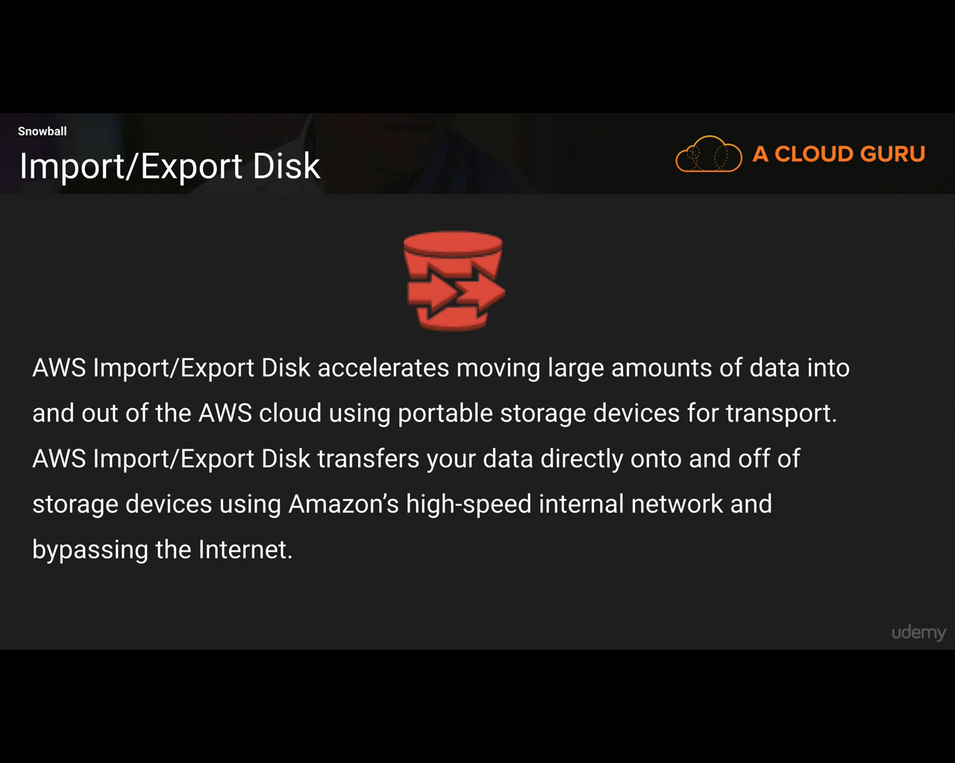

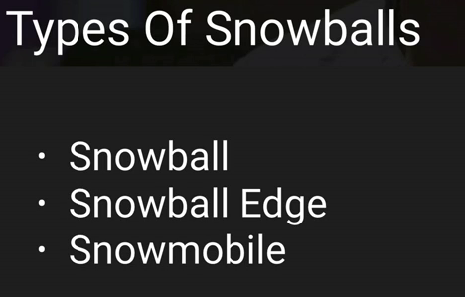

Understand the difference between different types of Snowballs.

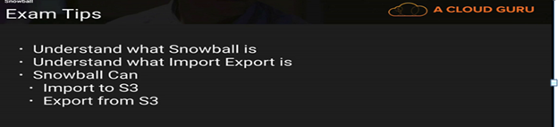

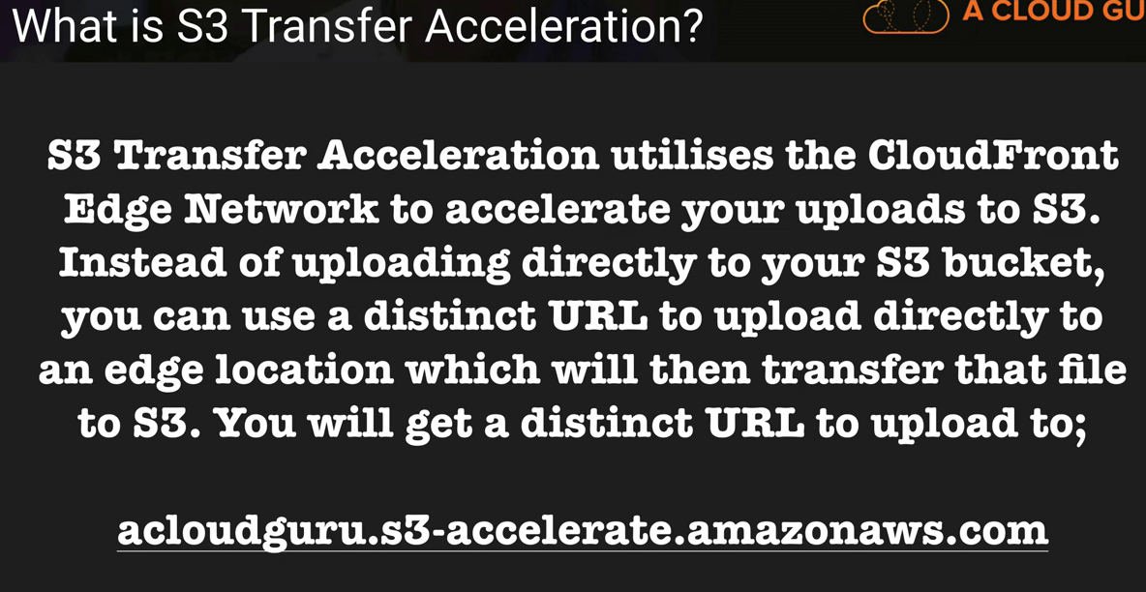

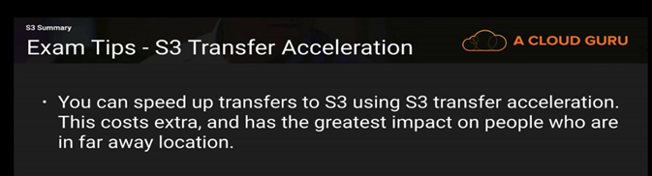

In Static website hosting, the name of the URL will be ***<bucket_name>.s3-website-<region>.amazonaws.com***

